CSE 581

**Lab 4: More Advanced Selects**

1. List all company names and number of orders they placed, for companies that placed 5 or more orders.

SELECT Customers.CompanyName, COUNT(*) AS [Order number]

FROM Orders, Customers

WHERE Orders.CustomerID = Customers.CustomerID

GROUP BY Orders.CustomerID, Customers.CompanyName

HAVING COUNT(*) > 5

1. List all employees (names and IDs only) and their corresponding managers (names only).

SELECT e1.EmployeeID, e1.FirstName+' '+ e1.LastName AS [employee name],

e2.FirstName + ' ' + e2.LastName AS manager

FROM Employees e1, Employees e2

WHERE e1.ReportsTo = e2.EmployeeID

1.

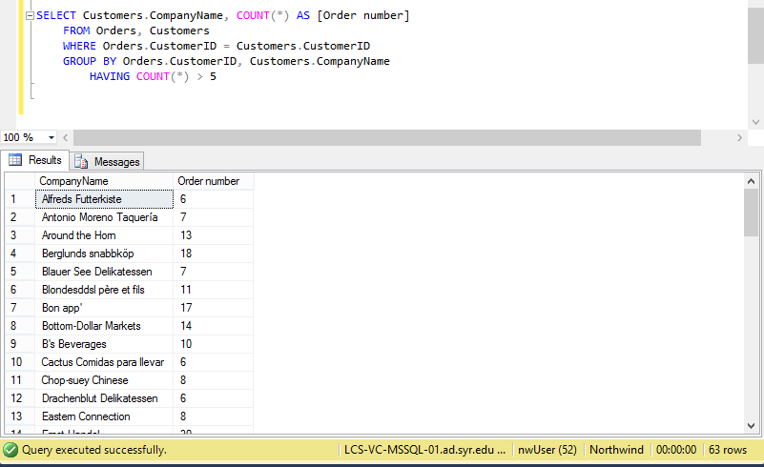

2.

